Internship Completion Certificate
This certifies that
G Naveen Kumar
Has concluded with success internship at Vigneshwara Traders as a Fullstack developer from 01/06/2026 - 27/06/2026. During his internship, G Naveen Kumar developed strong skills in software design, coding, debugging, and testing. His dedication and technical skills were a great asset to our team.
Date of issue: 28/06/2026  Certificate ID: VT-2026-N01 | 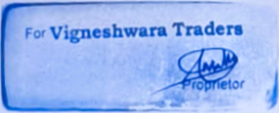  N Mallesh Yadav  Proprietor, Vigneshwara Traders

